**Week 5**

**-Tanisha Gotadke**

**1BM21CS229**

create database employeevck;

use employeevck;

create table dept(

deptno int,

dname varchar(20),

dloc varchar(20),

primary key(deptno));

create table employee(

empno int,

ename varchar(20),

mgr_no int,

hiredate date,

sal float,

deptno int,

primary key(empno),

foreign key(deptno) references dept(deptno)

on delete cascade on update cascade);

create table project(

pno int,

ploc varchar(20),

pname varchar(20),

primary key(pno));

create table incentives(

empno int,

incentive_date date,

incentive_amount float,

primary key(empno,incentive_date),

foreign key(empno) references employee(empno)

on delete cascade on update cascade);

create table assigned_to(

empno int,

pno int,

job_role varchar(20),

primary key(empno,pno),

foreign key(empno) references employee(empno)

on delete cascade on update cascade,

foreign key(pno) references project(pno)

on delete cascade on update cascade);

insert into dept values

('1','Cybersecurity','Pune'),

('2','Survey','Mysore'),

('3','Cloud Computing','Bangalore'),

('4','Web Development','Bangalore'),

('5','Data Analytics','Mumbai');

select * from dept;

insert into employee values

(101,'Ram',100,'2005-03-10',50000,3),

(102,'Sam',104,'2008-07-27',55000,1),

(103,'Hari',108,'2020-05-19',80000,2),

(104,'Vishnu',104,'2016-07-23',75000,1),

(105,'Vinod',101,'2009-12-07',70000,5);

insert into project values

(21,'Delhi','Webpage'),

(22,'Mysore','Google Cloud'),

(23,'Mumbai','App development'),

(24, 'Hyderabad','IOT'),

(25,'Bangalore','UI/UX');

insert into incentives values

(101,'2005-11-09',10000),

(102,'2009-12-07',20000),

(103,'2021-07-09',25000),

(104,'2018-09-03',20000);

insert into assigned_to values

(101,22,'Fullstack dev'),

(102,23,'UI/UX Designer'),

(103,21,'Data Analyst'),

(104,24,'Cybsec engineer'),

(105,25,'Blockchain eng');

select empno from project p,assigned_to a where p.pno=a.pno and p.ploc in('Bangalore','Hyderabad','Mysore');

select empno from employee e where e.empno not in (select empno from incentives);

select a.empno,a.pno,e.ename,e.deptno,d.dname,d.dloc,p.ploc from assigned_to a,project p,dept d,employee e where a.pno=p.pno and a.empno=e.empno and e.deptno=d.deptno and d.dloc=p.ploc;

**Query 1**

Retreive empno of all employees who work for projects in Bangalore, Mysuru and Hyderabad

select empno from project p,assigned_to a where p.pno=a.pno and p.ploc in('Bangalore','Hyderabad','Mysore');

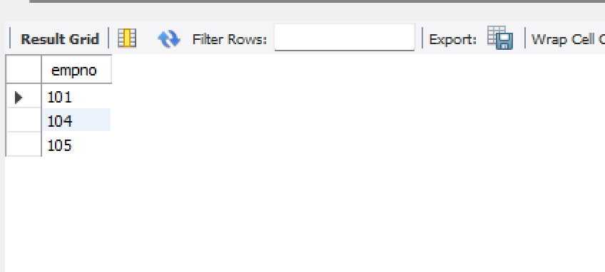

**Query 2**

Get employee id of those employees whop did not get incentives

select empno from employee e where e.empno not in (select empno from incentives);

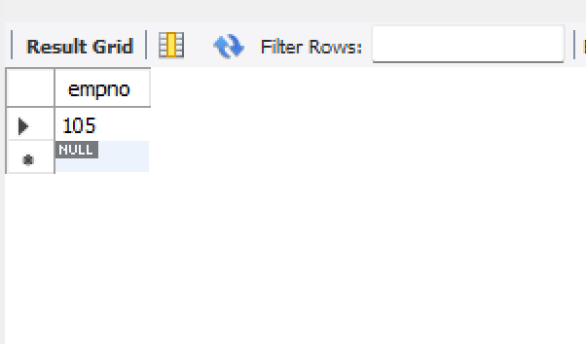

**Query 3**

Query to find emp name number,dept job role, dept location and project location for employees who are working for proj location same as dept location

select a.empno,a.pno,e.ename,e.deptno,d.dname,d.dloc,p.ploc from assigned_to a,project p,dept d,employee e where a.pno=p.pno and a.empno=e.empno and e.deptno=d.deptno and d.dloc=p.ploc;

